**[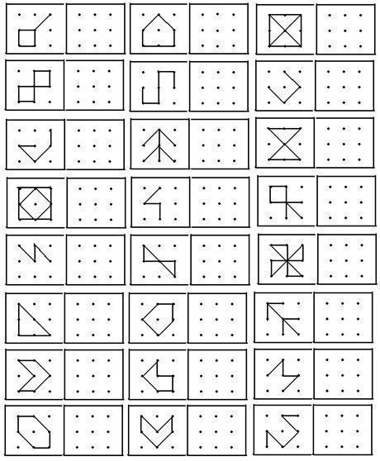](https://myhighschool.siwagner.com/school-activities/actividades-design-designer-designlife-gartentipps-kitchen-decor/)**